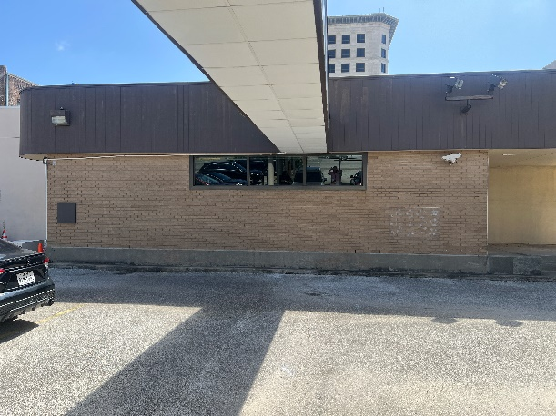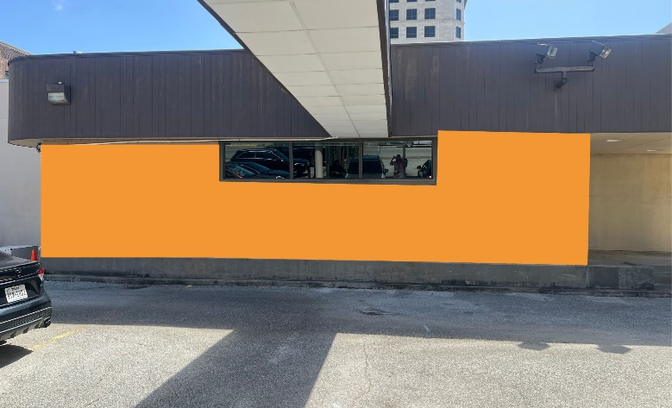
Mural location Marmo Motor bank Orange space is where mural will be located
CALL FOR ARTISTS- SOMA Mural Project
MURAL OPPORTUNITY AT MARMO INNOVATIONS
Deadline to Apply: July 22, 2025
Presented by Marmo Innovations & ARTS Downtown GTX
ARTS Downtown GTX, in partnership with Marmo Innovations, invites artists to submit proposals for a new public mural on the motor bank brick wall at 2121 Market Street in downtown Galveston.
This highly visible location is directly in front of SOMA (South of Market) Tattoo Shop, and we hope this project will not only reflect Galveston's creative spirit, but also become a draw for locals and visitors alike.

Project Details
- Location: Marmo Innovations Motor Bank, 2121 Market St., Galveston, TX
- Dimensions: 38.5 ft wide x 8.5 ft tall (see reference image)
- Project Budget: $5,000 total
  - $5,000 artist if artist preps wall or $4000 to artist if ARTS Downtown GTX Preps wall
- Theme: Open to the artist's interpretation, but must reflect Galveston's artistic vibe. We encourage creative proposals that resonate with the city’s cultural character and enhance its vibrant arts scene.

Eligibility
This call is open to all visual artists 18 years and older. We welcome submissions from muralists and artists with experience in public art. Artists with strong concepts that highlight community, creativity, and coastal culture are especially encouraged to apply.

Timeline
- Application Period: July 16 – August 22, 2025
- Proposal Deadline: Friday, August 22, 2025
- Review Period: August 25– August 29, 2025
- Artist Notification: Friday, August 29, 2025
- Installation Period: September 2, 2025 complete by September 13 art walk

How to Apply
Submit the following materials in a single PDF to Erica Delgadillo erica@marmoplaza.com
by 11:59 PM CST on Friday August 22, 2025:
- Artist Statement (max 1 page)
- Mural Proposal including concept sketch and brief written description
- Resume or Bio (max 1 pages)
- 3–5 Images of Previous Work
- List of Materials and Basic Budget Estimate

Selection Criteria
Proposals will be reviewed based on:
- Artistic quality and originality
- Connection to Galveston’s creative identity
- Visual impact and potential to attract public engagement
- Feasibility within budget and timeline
- Past experience and qualifications

Questions?
Contact us at erica@marmoplaza.com with the subject line "SOMA Mural ProjectArtist Call."

This project is proudly brought to life by ARTS Downtown GTX and Marmo Innovations, working together to celebrate Galveston's art-forward culture and grow the creative energy in the heart of downtown.
Let’s make something bold together.

